Experiment No. 1

A) Linear Search

Code:

#include <iostream>

using namespace std;

int main() {

int arr[11] = {22, 30, 33, 40, 44, 55, 60, 66, 77, 88, 11};

int n = 11;

int pos = -1;

int k;

for (int i = 0; i < n; i++) {

cout << arr[i] << " ";

}

cout << endl;

cout << "Enter the value you want to search for: ";

cin >> k;

for (int i = 0; i < n; i++) {

if (arr[i] == k) {

pos = i;

break;

}

}

if (pos == -1) {

cout << "Element is not present";

} else {

cout << k << " Found at location: " << pos;

}

return 0;

}

Output:

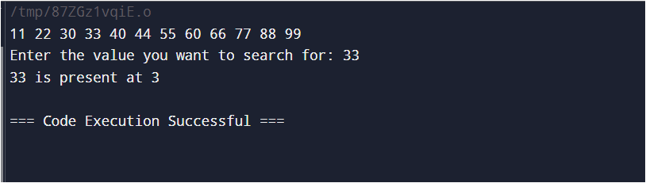

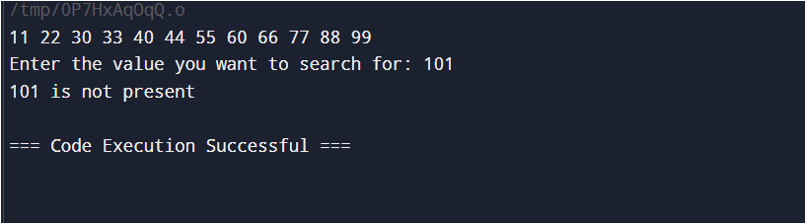

Experiment No. 1

B) Binary Search

Code:

#include <iostream>

using namespace std;

int main() {

int arr[12] = {11, 22, 30, 33, 40, 44, 55, 60, 66, 77, 88, 99};

for (int i = 0; i < 12; i++) {

cout << arr[i] << " ";

}

cout << endl;

int lb = 0;

int ub = (sizeof(arr) / sizeof(int)) - 1;

int mid;

int key, loc = -1;

cout << "Enter the value you want to search for: ";

cin >> key;

while (lb <= ub) {

mid = (lb + ub) / 2;

if (arr[mid] == key) {

loc = mid;

break;

} else if (key < arr[mid]) {

ub = mid - 1;

} else {

lb = mid + 1;

}

}

if (loc != -1) {

cout << key << " is present at " << loc;

} else {

cout << key << " is not present ";

}

return 0;

}

Output:

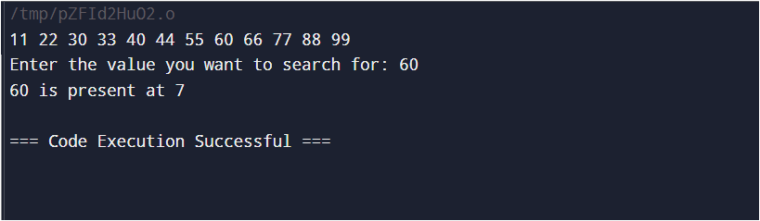

Experiment No. 2

A) Bubble Sort

Code:

#include <iostream>

using namespace std;

int main() {

int data[8] = {32, 51, 27, 85, 66, 23, 13, 57};

int n = sizeof(data) / sizeof(int);

int ptr = 0;

int temp;

cout << "Unsorted array:" << endl;

for (int k = 0; k < n; k++) {

cout << data[k] << " ";

}

cout << endl;

for (int k = 0; k < n; k++) {

while (ptr < n - k - 1) {

if (data[ptr] > data[ptr + 1]) {

temp = data[ptr];

data[ptr] = data[ptr + 1];

data[ptr + 1] = temp;

}

ptr += 1;

}

ptr = 0;

}

cout << "Sorted array:" << endl;

for (int k = 0; k < n; k++) {

cout << data[k] << " ";

}

cout << endl;

ptr = 0;

}

Output:

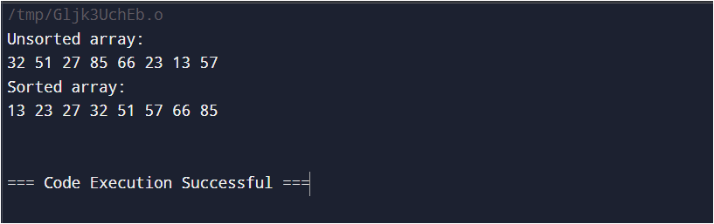

Experiment No. 2

B) Insertion Sort

Code:

#include <iostream>

using namespace std;

int main() {

int a[8] = {77, 33, 44, 11, 88, 22, 66, 55};

int i = 0;

int ptr;

int temp;

int n = sizeof(a) / sizeof(int);

cout << "Unsorted Array" << endl;

for (int i = 0; i < n; i++) {

cout << a[i] << " ";

}

for (int i = 1; i < n; i++) {

temp = a[i];

ptr = i - 1;

while (temp < a[ptr] && ptr >= 0) {

a[ptr + 1] = a[ptr];

ptr = ptr - 1;

}

a[ptr + 1] = temp;

}

cout << endl;

cout << "Sorted Array" << endl;

for (int i = 0; i < n; i++) {

cout << a[i] << " ";

}

return 0;

}

Output:

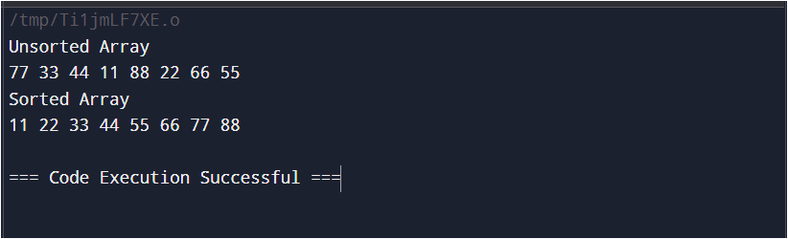

Experiment No. 2

C) Quick Sort

Code:

#include <iostream>

using namespace std;

// Partition function

int partition(int arr[], int low, int high) {

int pivot = arr[high]; // Pivot element

int i = low - 1; // Index of smaller element

for (int j = low; j < high; j++) {

// If the current element is smaller than or equal to the pivot

if (arr[j] <= pivot) {

i++; // Increment the index of the smaller element

swap(arr[i], arr[j]);

}

}

swap(arr[i + 1], arr[high]); // Move the pivot element to the correct position

return i + 1;

}

// QuickSort function

void quickSort(int arr[], int low, int high) {

if (low < high) {

int pi = partition(arr, low, high); // Partitioning index

// Recursively sort elements before and after partition

quickSort(arr, low, pi - 1);

quickSort(arr, pi + 1, high);

}

}

int main() {

int arr[] = {77, 33, 44, 11, 88, 22, 66, 55};

int n = sizeof(arr) / sizeof(int);

cout << "Original array: ";

for (int i = 0; i < n; i++) {

cout << arr[i] << " ";

}

cout << endl << endl;

quickSort(arr, 0, n - 1);

cout << "Sorted array: ";

for (int i = 0; i < n; i++) {

cout << arr[i] << " ";

}

return 0;

}

Output:

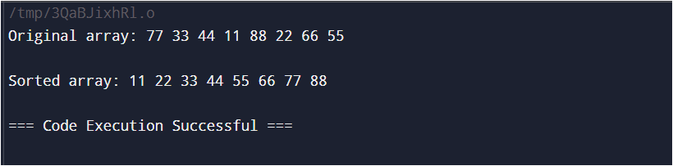

Experiment No. 3

Code:

#include <iostream>

using namespace std;

int main() {

int row, col;

cout << "Enter the number of rows: ";

cin >> row;

cout << "Enter the number of columns: ";

cin >> col;

int matrix[row][col];

cout << "Enter the matrix:" << endl;

for (int i = 0; i < row; i++) {

for (int j = 0; j < col; j++) {

cout << "(" << i << "," << j << ") = ";

cin >> matrix[i][j];

}

}

cout << "Original Matrix:" << endl;

for (int i = 0; i < row; i++) {

for (int j = 0; j < col; j++) {

cout << matrix[i][j] << " ";

}

cout << endl;

}

int size = 0;

for (int i = 0; i < row; i++) {

for (int j = 0; j < col; j++) {

if (matrix[i][j] != 0) {

size++;

}

}

}

// Making new matrix

int sparseMatrix[3][size];

int k = 0;

for (int i = 0; i < row; i++) {

for (int j = 0; j < col; j++) {

if (matrix[i][j] != 0) {

sparseMatrix[0][k] = i; // Row index

sparseMatrix[1][k] = j; // Column index

sparseMatrix[2][k] = matrix[i][j]; // Value

k++;

}

}

}

cout << "Sparse Matrix:" << endl;

for (int i = 0; i < 3; i++) {

if (i == 0) {

cout << "R : ";

} else if (i == 1) {

cout << "C : ";

} else {

cout << "V : ";

}

for (int j = 0; j < size; j++) {

cout << sparseMatrix[i][j] << " ";

}

cout << endl;

}

// Transpose matrix

int transposeMatrix[3][size];

for (int i = 0; i < 3; i++) {

if (i == 2) {

for (int j = 0; j < size; j++) {

transposeMatrix[i][j] = sparseMatrix[i][j];

}

} else {

for (int j = 0; j < size; j++) {

transposeMatrix[0][j] = sparseMatrix[1][j];

transposeMatrix[1][j] = sparseMatrix[0][j];

}

}

}

cout << "Transpose Matrix:" << endl;

for (int i = 0; i < 3; i++) {

if (i == 0) {

cout << "R : ";

} else if (i == 1) {

cout << "C : ";

} else {

cout << "V : ";

}

for (int j = 0; j < size; j++) {

cout << transposeMatrix[i][j] << " ";

}

cout << endl;

}

return 0;

}

Output:

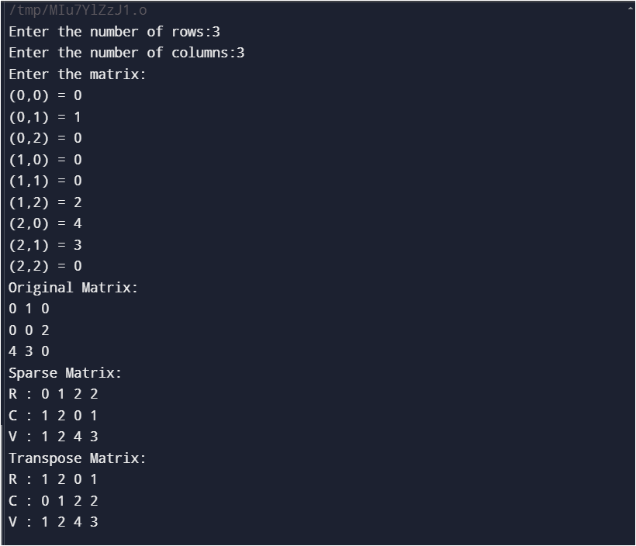

Experiment No. 4

Code:

#include <iostream>

using namespace std;

struct Node {

int data;

Node* next;

Node(int val) : data(val), next(nullptr) {}

};

// Function to add a node at the end

void addNode(Node*& head, int data) {

Node* newNode = new Node(data);

if (!head) {

head = newNode;

} else {

Node* temp = head;

while (temp->next) {

temp = temp->next;

}

temp->next = newNode;

}

}

// Function to delete a node with a specific value

void deleteNode(Node*& head, int data) {

if (!head) return;

if (head->data == data) {

Node* temp = head;

head = head->next;

delete temp;

return;

}

Node* temp = head;

while (temp->next && temp->next->data != data) {

temp = temp->next;

}

if (temp->next) {

Node* nodeToDelete = temp->next;

temp->next = temp->next->next;

delete nodeToDelete;

}

}

// Function to count the number of nodes

int countNodes(Node* head) {

int count = 0;

Node* temp = head;

while (temp) {

count++;

temp = temp->next;

}

return count;

}

// Function to display the list in reverse order

void displayReverse(Node* node) {

if (!node) return;

displayReverse(node->next);

cout << node->data << " ";

}

// Function to display the list

void displayList(Node* head) {

Node* temp = head;

while (temp) {

cout << temp->data << " ";

temp = temp->next;

}

cout << endl;

}

int main() {

Node* head = nullptr;

// Adding nodes

addNode(head, 10);

addNode(head, 20);

addNode(head, 30);

addNode(head, 40);

// Display list

cout << "Original list: ";

displayList(head);

// Count nodes

cout << "Total nodes: " << countNodes(head) << endl;

// Display reverse list

cout << "List in reverse order: ";

displayReverse(head);

cout << endl;

// Delete a node

deleteNode(head, 20);

cout << "After deleting 20: ";

displayList(head);

return 0;

}

Output:

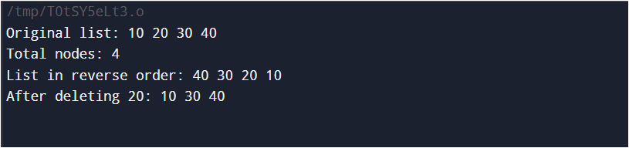

Experiment No. 5

Code:

#include <iostream>

using namespace std;

// Node class for representing each term in the polynomial

class Node {

public:

int coefficient;

int exponent;

Node* next;

Node(int coeff, int exp) {

coefficient = coeff;

exponent = exp;

next = nullptr;

}

};

// Function to add two polynomials

Node* add_polynomials(Node* poly1, Node* poly2) {

Node* result_head = new Node(0, 0);

Node* current_result = result_head;

while (poly1 != nullptr || poly2 != nullptr) {

if (poly1 == nullptr) {

current_result->next = poly2;

break;

} else if (poly2 == nullptr) {

current_result->next = poly1;

break;

}

if (poly1->exponent > poly2->exponent) {

current_result->next = new Node(poly1->coefficient, poly1->exponent);

poly1 = poly1->next;

} else if (poly1->exponent < poly2->exponent) {

current_result->next = new Node(poly2->coefficient, poly2->exponent);

poly2 = poly2->next;

} else {

int new_coefficient = poly1->coefficient + poly2->coefficient;

if (new_coefficient != 0) {

current_result->next = new Node(new_coefficient, poly1->exponent);

}

poly1 = poly1->next;

poly2 = poly2->next;

}

current_result = current_result->next;

}

return result_head->next;

}

// Function to display the polynomial

void display_polynomial(Node* poly) {

while (poly != nullptr) {

cout << poly->coefficient << "x^" << poly->exponent;

if (poly->next != nullptr && poly->next->coefficient >= 0) {

cout << " + ";

}

poly = poly->next;

}

cout << endl;

}

int main() {

// Polynomial 1: 3x^2 + 2x^1 + 5

Node* poly1 = new Node(3, 2);

poly1->next = new Node(2, 1);

poly1->next->next = new Node(5, 0);

// Polynomial 2: -1x^2 + 4x^1 - 1

Node* poly2 = new Node(-1, 2);

poly2->next = new Node(4, 1);

poly2->next->next = new Node(-1, 0);

// Add the two polynomials

Node* result = add_polynomials(poly1, poly2);

// Display the polynomials

cout << "Polynomial 1: ";

display_polynomial(poly1);

cout << "Polynomial 2: ";

display_polynomial(poly2);

cout << "Sum: ";

display_polynomial(result);

return 0;

}

Output:

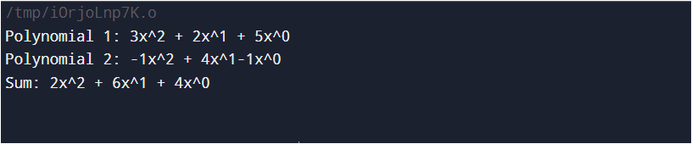

Experiment No. 6

Code:

#include <bits/stdc++.h>

using namespace std;

// Creating a linked list

class Node {

public:

int data;

Node* link;

// Constructor

Node(int n) {

this->data = n;

this->link = NULL;

}

};

class Stack {

Node* top;

public:

Stack() { top = NULL; }

void push(int data) {

// Create new node temp and allocate memory in heap

Node* temp = new Node(data);

// Check if stack (heap) is full. Inserting an element would

// lead to stack overflow

if (!temp) {

cout << "\nStack Overflow";

exit(1);

}

// Initialize data into temp data field

temp->data = data;

// Put top pointer reference into temp link

temp->link = top;

// Make temp as top of Stack

top = temp;

}

// Utility function to check if the stack is empty or not

bool isEmpty() {

// If top is NULL it means that there are no elements in the stack

return top == NULL;

}

// Utility function to return the top element in a stack

int peek() {

// If stack is not empty, return the top element

if (!isEmpty())

return top->data;

else

exit(1);

}

// Function to remove a key from the given stack

void pop() {

Node* temp;

// Check for stack underflow

if (top == NULL) {

cout << "\nStack Underflow" << endl;

exit(1);

} else {

// Assign top to temp

temp = top;

// Assign second node to top

top = top->link;

// Release memory of the top node

free(temp);

}

}

// Function to print all the elements of the stack

void display() {

Node* temp;

// Check for stack underflow

if (top == NULL) {

cout << "\nStack Underflow";

exit(1);

} else {

temp = top;

while (temp != NULL) {

// Print node data

cout << temp->data;

// Assign temp link to temp

temp = temp->link;

if (temp != NULL)

cout << " -> ";

}

}

}

};

// Driven Program

int main() {

// Creating a stack

Stack s;

// Push the elements of stack

s.push(11);

s.push(22);

s.push(33);

s.push(44);

s.push(55);

s.push(66);

s.push(77);

// Display stack elements

s.display();

// Print top element of stack

cout << "\nTop element is " << s.peek() << endl;

// Delete top elements of stack

s.pop();

s.pop();

// Display stack elements

s.display();

// Print top element of stack

cout << "\nTop element is " << s.peek() << endl;

return 0;

}

Output:

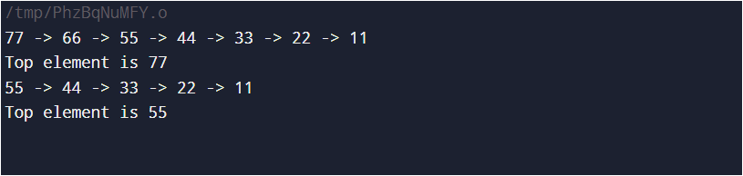

Experiment No. 7

Code:

// expression where tokens are

// separated by space.

#include <bits/stdc++.h>

using namespace std;

// Function to find precedence of operators.

int precedence(char op) {

if (op == '+' || op == '-')

return 1;

if (op == '*' || op == '/')

return 2;

return 0;

}

// Function to perform arithmetic operations.

int applyOp(int a, int b, char op) {

switch (op) {

case '+': return a + b;

case '-': return a - b;

case '*': return a * b;

case '/': return a / b;

}

}

// Function that returns value of expression after evaluation.

int evaluate(string tokens) {

int i;

// stack to store integer values.

stack<int> values;

// stack to store operators.

stack<char> ops;

for (i = 0; i < tokens.length(); i++) {

// Current token is a whitespace, skip it.

if (tokens[i] == ' ')

continue;

// Current token is an opening brace, push it to 'ops'

else if (tokens[i] == '(') {

ops.push(tokens[i]);

}

// Current token is a number, push it to stack for numbers.

else if (isdigit(tokens[i])) {

int val = 0;

// There may be more than one digits in number.

while (i < tokens.length() && isdigit(tokens[i])) {

val = (val * 10) + (tokens[i] - '0');

i++;

}

values.push(val);

// right now the i points to the character next to the digit,

// since the for loop also increases the i, we would skip one

// token position; we need to decrease the value of i by 1

// to correct the offset.

i--;

}

// Closing brace encountered, solve entire brace.

else if (tokens[i] == ')') {

while (!ops.empty() && ops.top() != '(') {

int val2 = values.top();

values.pop();

int val1 = values.top();

values.pop();

char op = ops.top();

ops.pop();

values.push(applyOp(val1, val2, op));

}

// pop opening brace.

if (!ops.empty())

ops.pop();

}

// Current token is an operator.

else {

// While top of 'ops' has same or greater precedence

// to current token, which is an operator. Apply operator

// on top of 'ops' to top two elements in values stack.

while (!ops.empty() && precedence(ops.top()) >= precedence(tokens[i])) {

int val2 = values.top();

values.pop();

int val1 = values.top();

values.pop();

char op = ops.top();

ops.pop();

values.push(applyOp(val1, val2, op));

}

// Push current token to 'ops'.

ops.push(tokens[i]);

}

}

// Entire expression has been parsed at this point, apply

// remaining ops to remaining values.

while (!ops.empty()) {

int val2 = values.top();

values.pop();

int val1 = values.top();

values.pop();

char op = ops.top();

ops.pop();

values.push(applyOp(val1, val2, op));

}

// Top of 'values' contains result, return it.

return values.top();

}

int main() {

cout << "10 + 2 * 6 = " << evaluate("10 + 2 * 6") << "\n";

cout << "100 * 2 + 12 = " << evaluate("100 * 2 + 12") << "\n";

cout << "100 * ( 2 + 12 ) = " << evaluate("100 * ( 2 + 12 )") << "\n";

cout << "100 * ( 2 + 12 ) / 14 = " << evaluate("100 * ( 2 + 12 ) / 14") << "\n";

return 0;

}

Output:

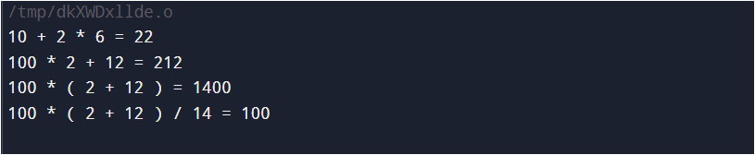

Experiment No. 8

Code:

#include <iostream>

using namespace std;

void towers_of_hanoi(int n, const string& a, const string& b, const string& c) {

if (n == 1) {

++cnt;

cout << "\n" << cnt << ": Move disk 1 from " << a << " to " << c;

return;

} else {

towers_of_hanoi(n - 1, a, c, b);

++cnt;

cout << "\n" << cnt << ": Move disk " << n << " from " << a << " to " << c;

towers_of_hanoi(n - 1, b, a, c);

return;

}

int cnt = 0;

int main() {

int n;

cout << "Enter number of discs: ";

cin >> n;

towers_of_hanoi(n, "Tower 1", "Tower 2", "Tower 3");

return 0;

}

Output:

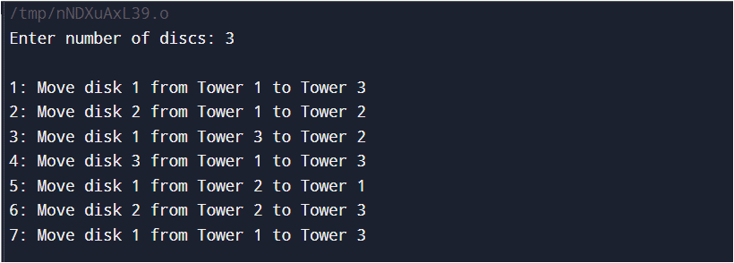

Experiment No. 9

Code:

#include <iostream>

using namespace std;

#define SIZE 5

class Dequeue {

int a[SIZE];

int front, rear, count;

public:

Dequeue();

void add_at_beg(int);

void add_at_end(int);

void delete_fr_front();

void delete_fr_rear();

void display();

};

Dequeue::Dequeue() {

front = -1;

rear = -1;

count = 0;

}

void Dequeue::add_at_beg(int item) {

if (count >= SIZE) {

cout << "\nInsertion is not possible: overflow!!!";

return;

}

if (front == -1) {

front = 0;

rear = 0;

} else if (front == 0) {

cout << "\nInsertion is not possible: front is at the beginning!!!";

return;

} else {

front--;

}

a[front] = item;

count++;

}

void Dequeue::add_at_end(int item) {

if (count >= SIZE) {

cout << "\nInsertion is not possible: overflow!!!";

return;

}

if (front == -1) {

front = 0;

rear = 0;

} else {

rear++;

}

a[rear] = item;

count++;

}

void Dequeue::display() {

if (front == -1) {

cout << "\nDequeue is empty!";

return;

}

cout << "\nElements in Dequeue: ";

for (int i = front; i <= rear; i++) {

cout << a[i] << " ";

}

cout << endl;

}

void Dequeue::delete_fr_front() {

if (front == -1) {

cout << "Deletion is not possible: Dequeue is empty";

return;

}

cout << "The deleted element is " << a[front] << endl;

front++;

if (front > rear) {

front = rear = -1; // Reset if empty

}

count--;

}

void Dequeue::delete_fr_rear() {

if (front == -1) {

cout << "Deletion is not possible: Dequeue is empty";

return;

}

cout << "The deleted element is " << a[rear] << endl;

rear--;

if (rear < front) {

front = rear = -1; // Reset if empty

}

count--;

}

int main() {

int c, item;

Dequeue d1;

do {

cout << "\n\n****DEQUEUE OPERATION****\n";

cout << "\n1- Insert at beginning";

cout << "\n2- Insert at end";

cout << "\n3- Display";

cout << "\n4- Deletion from front";

cout << "\n5- Deletion from rear";

cout << "\n6- Exit";

cout << "\nEnter your choice (1-6): ";

cin >> c;

switch (c) {

case 1:

cout << "Enter the element to be inserted: ";

cin >> item;

d1.add_at_beg(item);

break;

case 2:

cout << "Enter the element to be inserted: ";

cin >> item;

d1.add_at_end(item);

break;

case 3:

d1.display();

break;

case 4:

d1.delete_fr_front();

break;

case 5:

d1.delete_fr_rear();

break;

case 6:

exit(0);

break;

default:

cout << "Invalid choice";

break;

}

} while (true);

return 0;

}

Output:

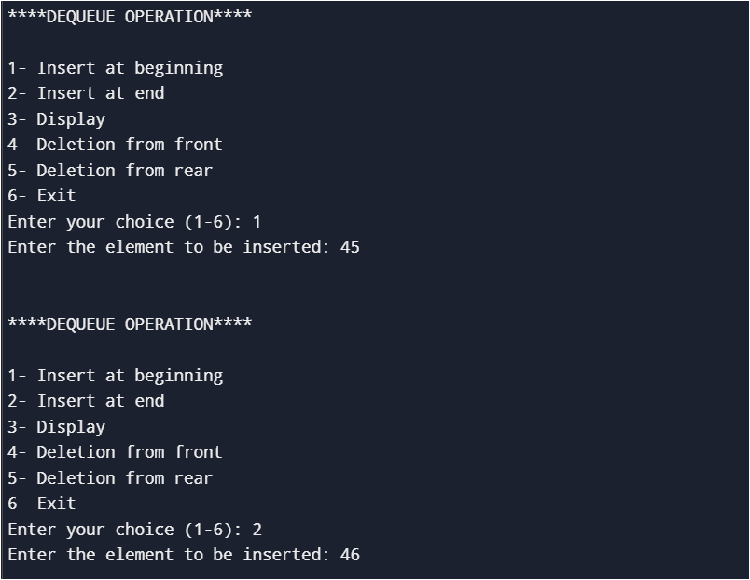

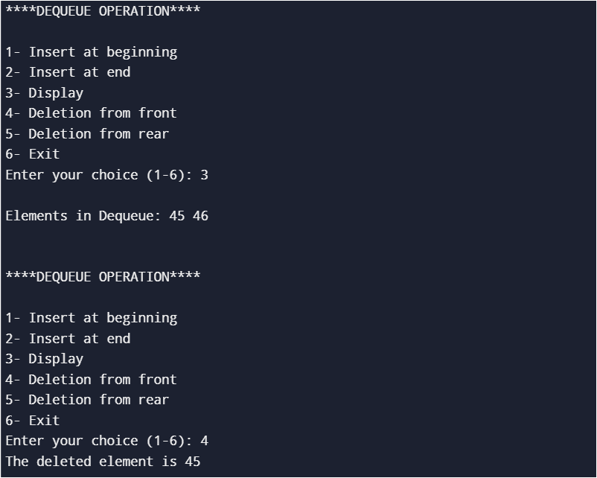

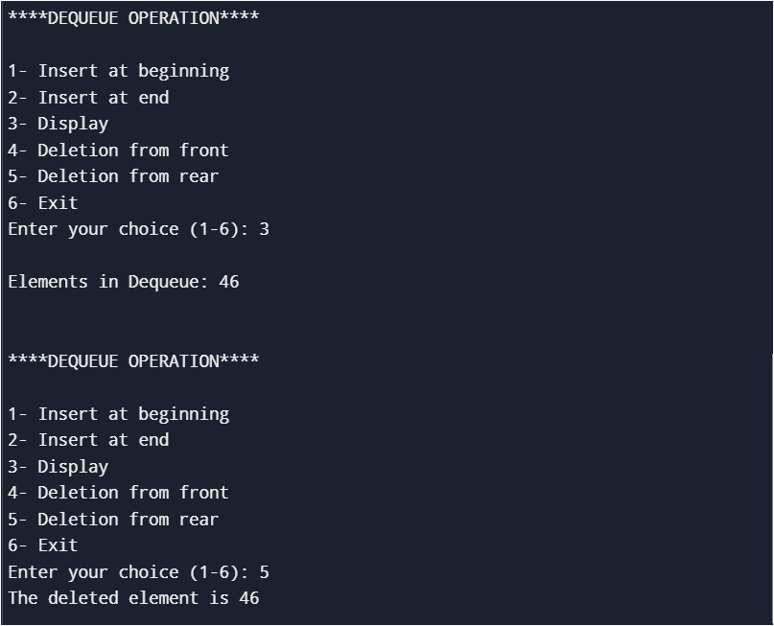

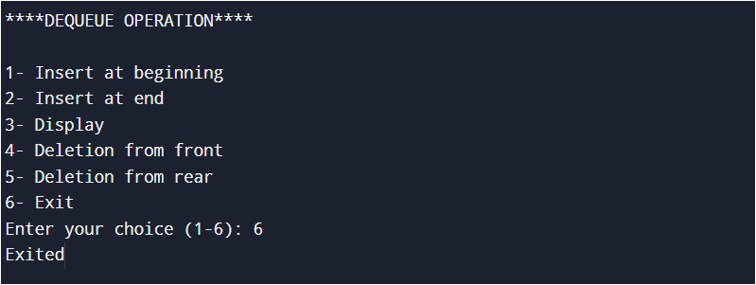

Experiment No. 10

Code:

#include <iostream>

using namespace std;

struct node {

int data;

node *L;

node *R;

};

class bst {

public:

node *root;

int count;

bst() {

root = NULL;

count = 0;

}

void create();

void insert(node*, node*);

void disin(node*);

void dispre(node*);

void dispost(node*);

void search(node*, int);

int height(node*);

void mirror(node*);

void min(node*);

};

void bst::create() {

char ans;

do {

node *temp = new node;

cout << "Enter the data: ";

cin >> temp->data;

temp->L = NULL;

temp->R = NULL;

if (root == NULL) {

root = temp;

} else {

insert(root, temp);

}

count++;

cout << "Do you want to insert more value (y/n)? ";

cin >> ans;

cout << endl;

} while (ans == 'y');

cout << "The Total number of nodes is: " << count << endl;

}

void bst::insert(node *root, node* temp) {

if (temp->data > root->data) {

if (root->R == NULL) {

root->R = temp;

} else {

insert(root->R, temp);

}

} else {

if (root->L == NULL) {

root->L = temp;

} else {

insert(root->L, temp);

}

}

}

void bst::disin(node *root) {

if (root != NULL) {

disin(root->L);

cout << root->data << "\t";

disin(root->R);

}

}

void bst::dispre(node *root) {

if (root != NULL) {

cout << root->data << "\t";

dispre(root->L);

dispre(root->R);

}

}

void bst::dispost(node *root) {

if (root != NULL) {

dispost(root->L);

dispost(root->R);

cout << root->data << "\t";

}

}

void bst::search(node *root, int key) {

cout << "\nEnter your key: ";

cin >> key;

node *temp = root;

while (temp != NULL) {

if (key == temp->data) {

cout << "KEY FOUND\n";

return;

}

if (key > temp->data) {

temp = temp->R;

} else {

temp = temp->L;

}

}

cout << "KEY NOT FOUND\n";

}

int bst::height(node *root) {

if (root == NULL) {

return 0;

}

int hl = height(root->L);

int hr = height(root->R);

return 1 + max(hl, hr); // Return height from both sides

}

void bst::min(node *root) {

node *temp = root;

while (temp && temp->L != NULL) {

temp = temp->L;

}

if (temp) {

cout << "The minimum element is: " << temp->data << endl;

} else {

cout << "The tree is empty." << endl;

}

}

void bst::mirror(node *root) {

if (root != NULL) {

mirror(root->L);

mirror(root->R);

swap(root->L, root->R); // Swap the left and right children

}

}

int main() {

bst t;

int ch;

char ans;

do {

cout << "\n1) Insert new node\n"

<< "2) Number of nodes in longest path\n"

<< "3) Minimum\n"

<< "4) Mirror\n"

<< "5) Search\n"

<< "6) Inorder\n"

<< "7) Preorder\n"

<< "8) Postorder\n";

cout << "Enter your choice (1-8): ";

cin >> ch;

switch (ch) {

case 1:

t.create();

break;

case 2:

cout << "Number of nodes in longest path: " << t.height(t.root) << endl;

break;

case 3:

t.min(t.root);

break;

case 4:

t.mirror(t.root);

cout << "The mirror of tree is: ";

t.disin(t.root);

break;

case 5:

t.search(t.root, 0); // Passing 0 as the initial value

break;

case 6:

cout << "\n***************INORDER**************" << endl;

t.disin(t.root);

break;

case 7:

cout << "\n***************PREORDER**************" << endl;

t.dispre(t.root);

break;

case 8:

cout << "\n*******************POSTORDER**************" << endl;

t.dispost(t.root);

break;

default:

cout << "Invalid choice" << endl;

}

cout << "\nDo you want to continue (y/n)? ";

cin >> ans;

} while (ans == 'y');

return 0;

}

Output:

